**Class:** Final Year (Computer Science and Engineering)

**Year:** 2022-23 **Semester:** 1

**Course:** High Performance Computing Lab

**Practical No. 10**

**Exam Seat No: 2019BTECS00064**

**Name – Kunal Santosh Kadam**

**Problem Statement 1:**

Implement Matrix-matrix Multiplication using global memory in CUDA C. Analyze and tune the program for getting maximum speed up. Do Profiling and state what part of the code takes the huge amount of time to execute

**Screenshot #:**

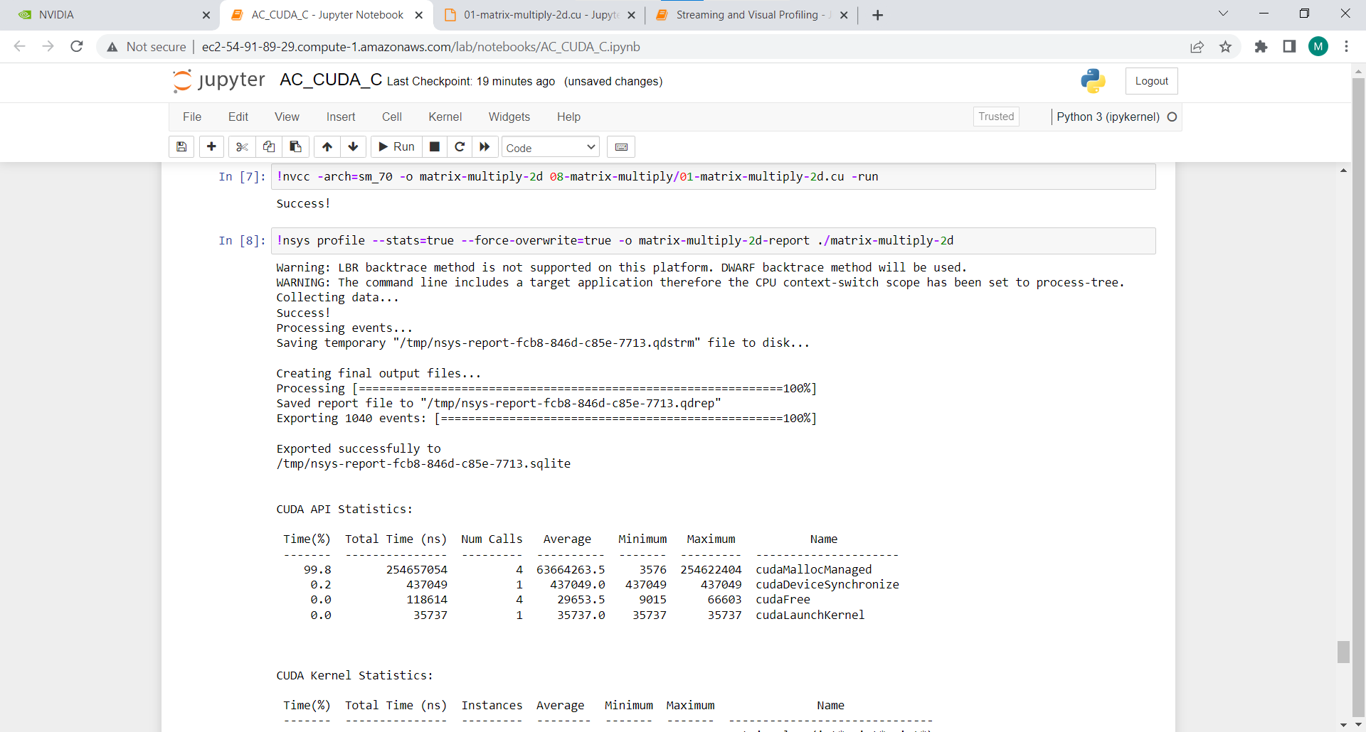

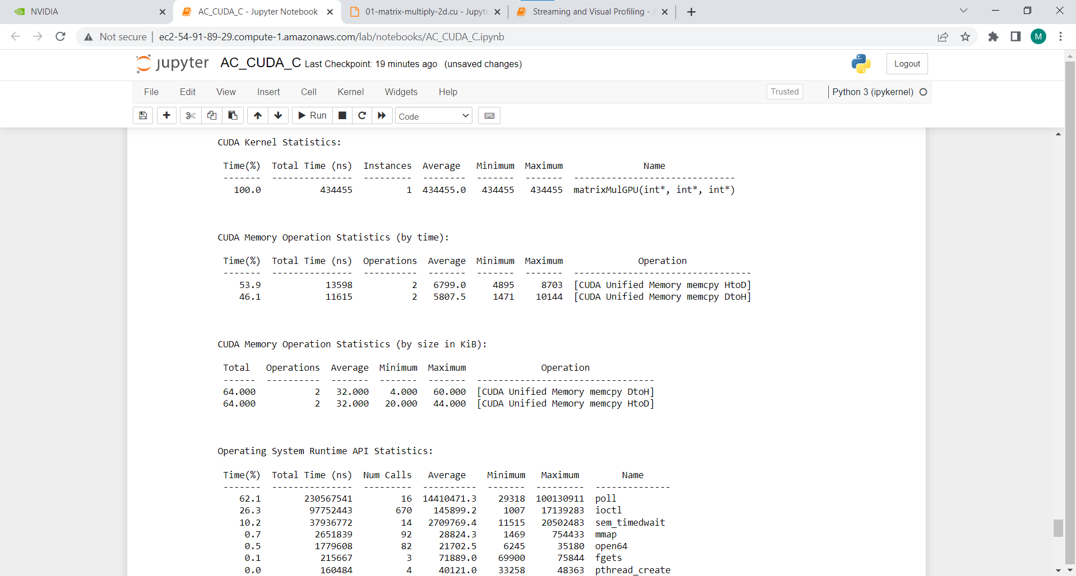

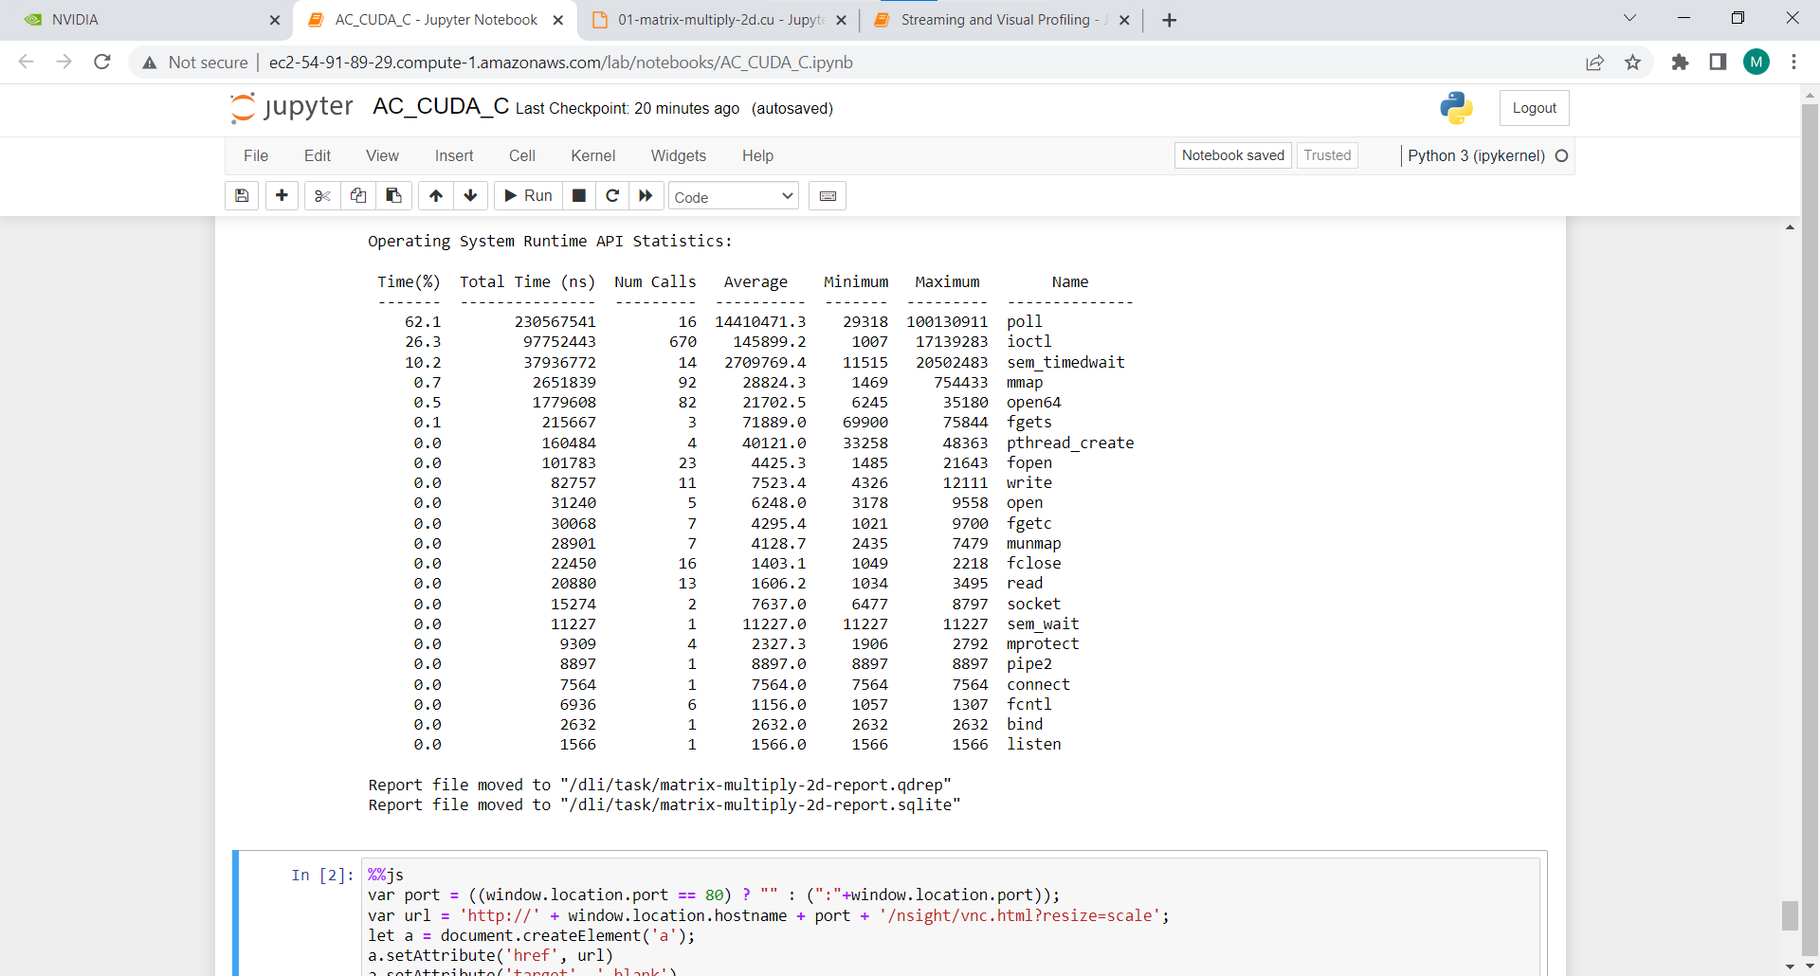

**Information #:**

#include <stdio.h>

#define N 64

__global__ void matrixMulGPU( int * a, int * b, int * c )

{

int val = 0;

int row = blockIdx.x * blockDim.x + threadIdx.x;

int col = blockIdx.y * blockDim.y + threadIdx.y;

if (row < N && col < N)

{

for ( int k = 0; k < N; ++k )

val += a[row * N + k] * b[k * N + col];

c[row * N + col] = val;

}

}

void matrixMulCPU( int * a, int * b, int * c )

{

int val = 0;

for( int row = 0; row < N; ++row )

for( int col = 0; col < N; ++col )

{

val = 0;

for ( int k = 0; k < N; ++k )

val += a[row * N + k] * b[k * N + col];

c[row * N + col] = val;

}

}

int main()

{

int *a, *b, *c_cpu, *c_gpu;

int size = N * N * sizeof (int); // Number of bytes of an N x N matrix

// Allocate memory

cudaMallocManaged (&a, size);

cudaMallocManaged (&b, size);

cudaMallocManaged (&c_cpu, size);

cudaMallocManaged (&c_gpu, size);

// Initialize memory

for( int row = 0; row < N; ++row )

for( int col = 0; col < N; ++col )

{

a[row*N + col] = row;

b[row*N + col] = col+2;

c_cpu[row*N + col] = 0;

c_gpu[row*N + col] = 0;

}

dim3 threads_per_block (16, 16, 1); // A 16 x 16 block threads

dim3 number_of_blocks ((N / threads_per_block.x) + 1, (N / threads_per_block.y) + 1, 1);

matrixMulGPU <<< number_of_blocks, threads_per_block >>> ( a, b, c_gpu );

cudaDeviceSynchronize(); // Wait for the GPU to finish before proceeding

// Call the CPU version to check our work

matrixMulCPU( a, b, c_cpu );

// Compare the two answers to make sure they are equal

bool error = false;

for( int row = 0; row < N && !error; ++row )

for( int col = 0; col < N && !error; ++col )

if (c_cpu[row * N + col] != c_gpu[row * N + col])

{

printf("FOUND ERROR at c[%d][%d]\n", row, col);

error = true;

break;

}

if (!error)

printf("Success!\n");

// Free all our allocated memory

cudaFree(a);

cudaFree(b);

cudaFree( c_cpu );

cudaFree( c_gpu );

}

**Problem Statement 2:**

Implement Matrix-Matrix Multiplication using shared memory in CUDA C. Analyze and tune the program for getting maximum speed up. Do Profiling and state what part of the code takes the huge amount of time to execute.

**Screenshot #:**

Applying 512 blocks with 32 threads each block

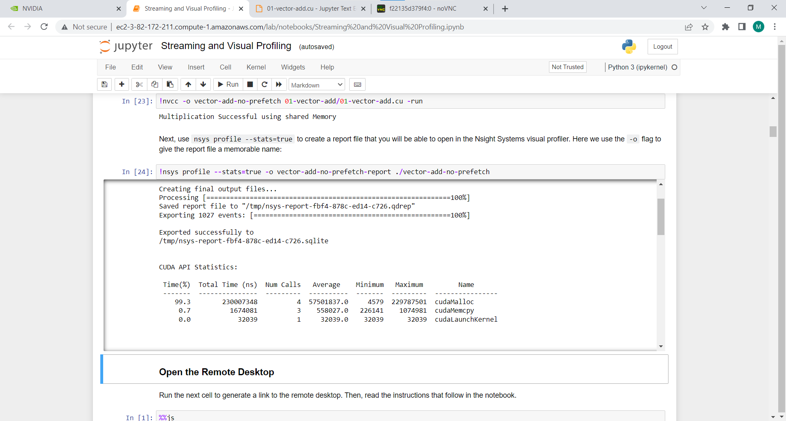

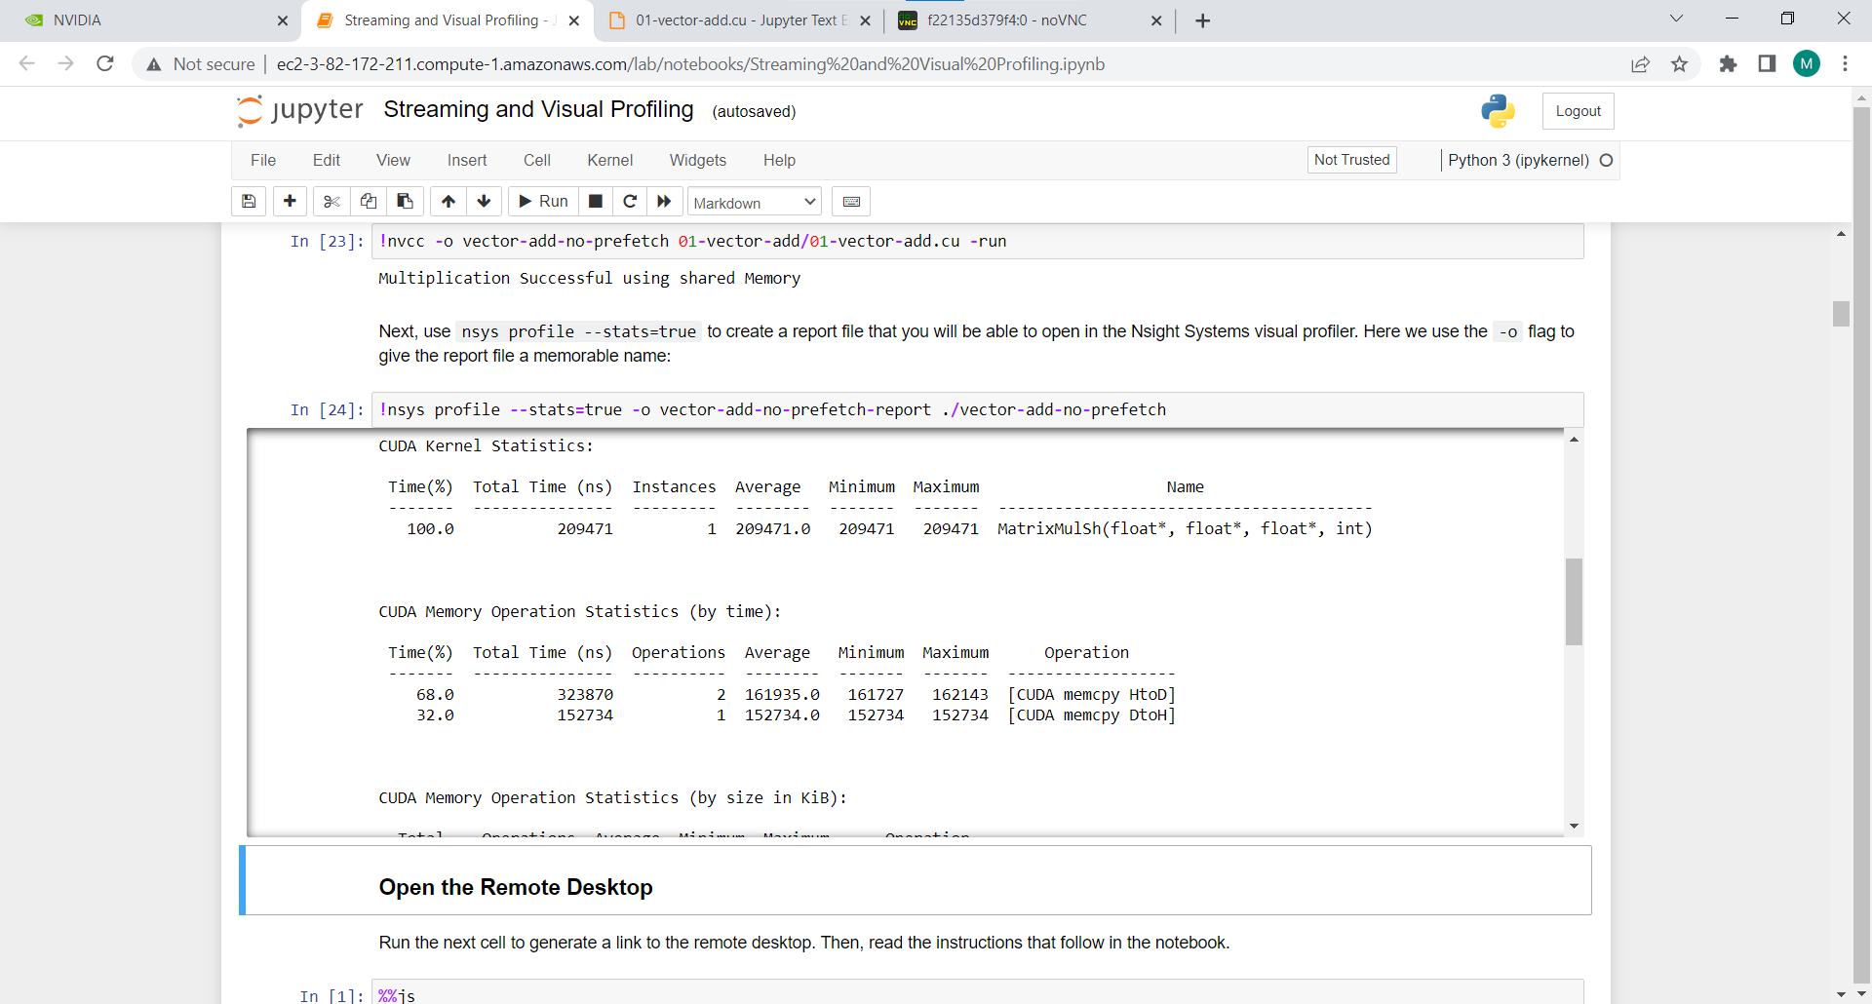

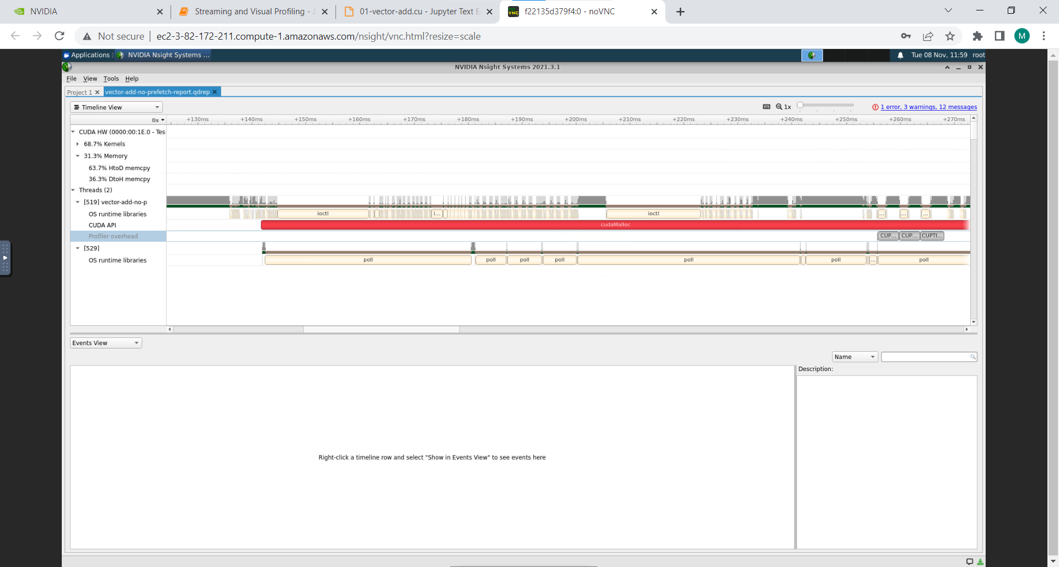

Applying 256 blocks with 16 threads each block

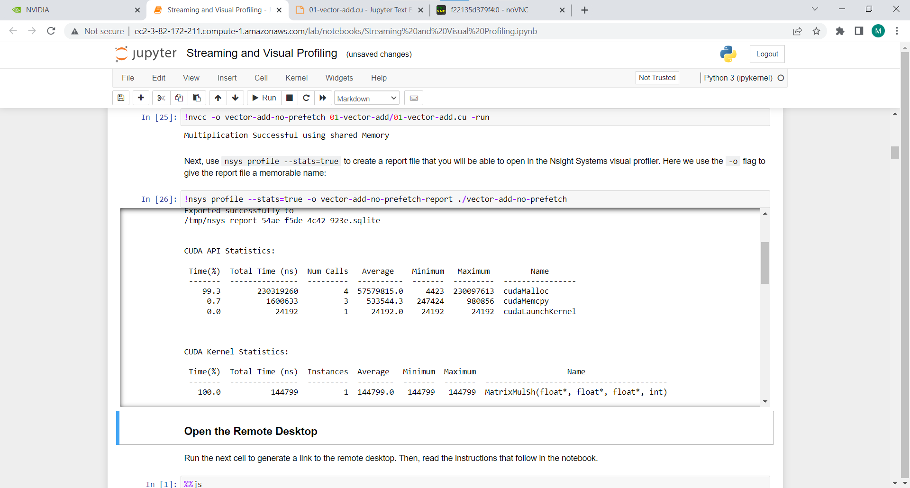

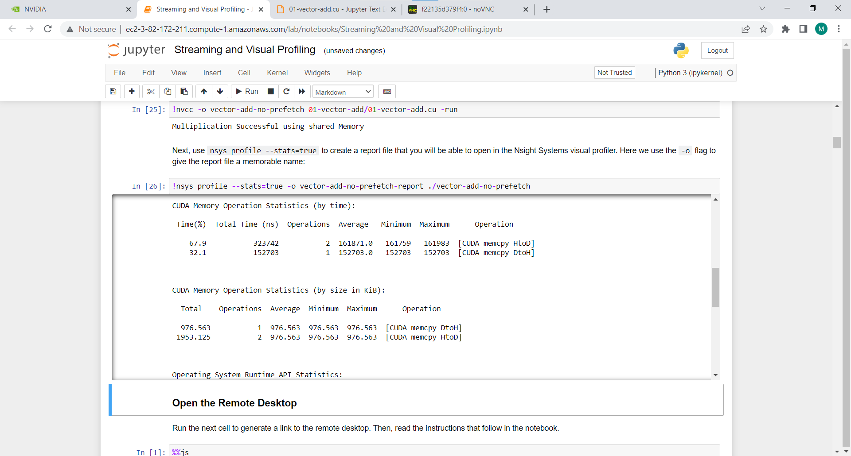

**Information #:**

#include <stdio.h>

#include <math.h>

#define TILE_WIDTH 2

/*matrix multiplication kernels*/

// shared

__global__ void

MatrixMulSh( float *Md , float *Nd , float *Pd , const int WIDTH )

{

//Taking shared array to break the MAtrix in Tile widht and fatch them in that array per ele

__shared__ float Mds [TILE_WIDTH][TILE_WIDTH] ;

__shared__ float Nds [TILE_WIDTH][TILE_WIDTH] ;

// calculate thread id

unsigned int col = TILE_WIDTH*blockIdx.x + threadIdx.x ;

unsigned int row = TILE_WIDTH*blockIdx.y + threadIdx.y ;

for (int m = 0 ; m<WIDTH/TILE_WIDTH ; m++ ) // m indicate number of phase

{

Mds[threadIdx.y][threadIdx.x] = Md[row*WIDTH + (m*TILE_WIDTH + threadIdx.x)] ;

Nds[threadIdx.y][threadIdx.x] = Nd[ ( m*TILE_WIDTH + threadIdx.y) * WIDTH + col] ;

__syncthreads() ; // for syncronizeing the threads

// Do for tile

for ( int k = 0; k<TILE_WIDTH ; k++ )

Pd[row*WIDTH + col]+= Mds[threadIdx.x][k] * Nds[k][threadIdx.y] ;

__syncthreads() ; // for syncronizeing the threads

}

}

// main routine

int main ()

{

const int WIDTH = 500;

float array1_h[WIDTH][WIDTH] ,array2_h[WIDTH][WIDTH], M_result_array_h[WIDTH][WIDTH] ;

float *array1_d , *array2_d ,*result_array_d ,*M_result_array_d ; // device array

int i , j ;

//input in host array

for ( i = 0 ; i<WIDTH ; i++ )

{

for (j = 0 ; j<WIDTH ; j++ )

{

array1_h[i][j] = (i + 2*j) %500 ;

array2_h[i][j] = (i + 3*j) %500 ;

}

}

//create device array cudaMalloc ( (void **)&array_name, sizeofmatrixinbytes) ;

cudaMalloc((void **) &array1_d , WIDTH*WIDTH*sizeof (int) ) ;

cudaMalloc((void **) &array2_d , WIDTH*WIDTH*sizeof (int) ) ;

//copy host array to device array; cudaMemcpy ( dest , source , WIDTH , direction )

cudaMemcpy ( array1_d , array1_h , WIDTH*WIDTH*sizeof (int) , cudaMemcpyHostToDevice ) ;

cudaMemcpy ( array2_d , array2_h , WIDTH*WIDTH*sizeof (int) , cudaMemcpyHostToDevice ) ;

//allocating memory for resultent device array

cudaMalloc((void **) &result_array_d , WIDTH*WIDTH*sizeof (int) ) ;

cudaMalloc((void **) &M_result_array_d , WIDTH*WIDTH*sizeof (int) ) ;

MatrixMulSh<<<512,32>>> ( array1_d , array2_d ,M_result_array_d , WIDTH) ;

// all gpu function blocked till kernel is working

//copy back result_array_d to result_array_h

cudaMemcpy(M_result_array_h , M_result_array_d , WIDTH*WIDTH*sizeof(int) ,cudaMemcpyDeviceToHost) ;

printf("Multiplication Successful using shared Memory");

}

**Problem Statement 4:**

Implement 2D Convolution using shared memory using CUDA C. Analyze and tune the program for getting maximum speed up. Do Profiling and state what part of the code takes the huge amount of time to execute.

**Screenshot #:**

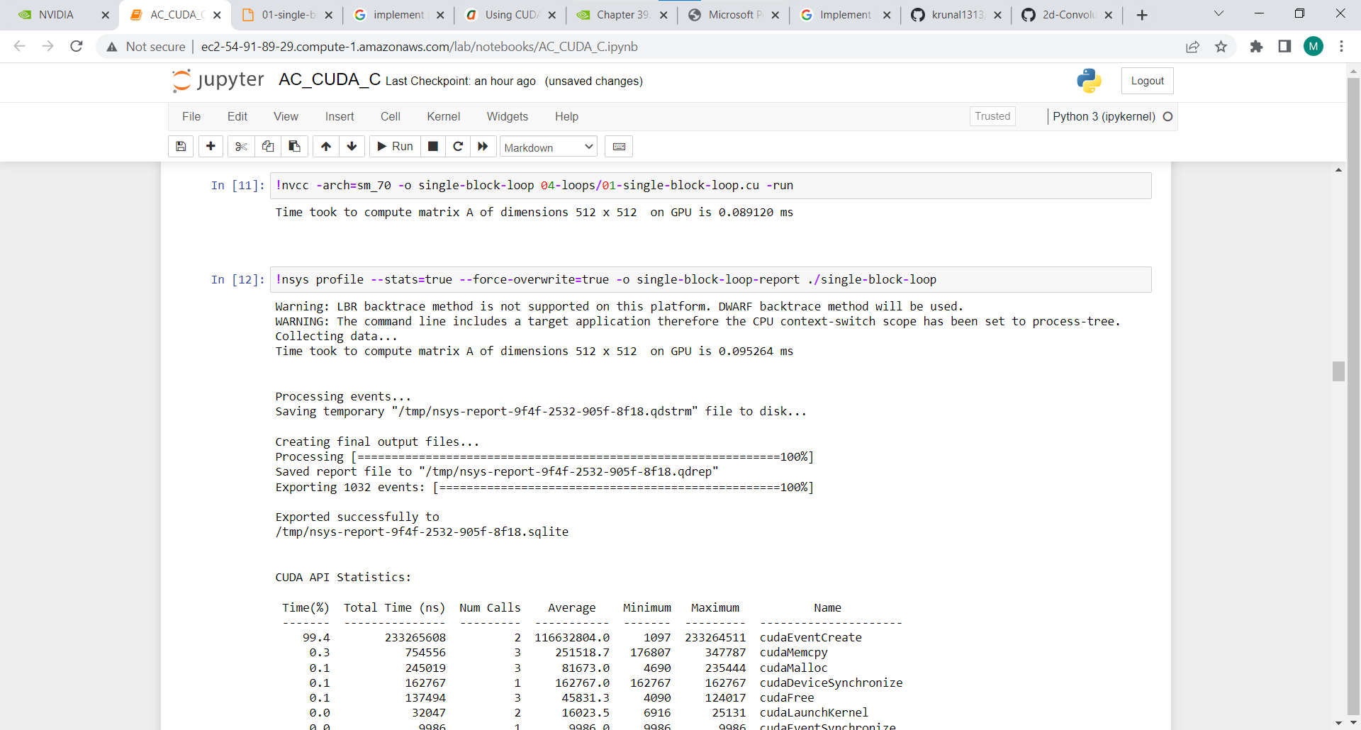

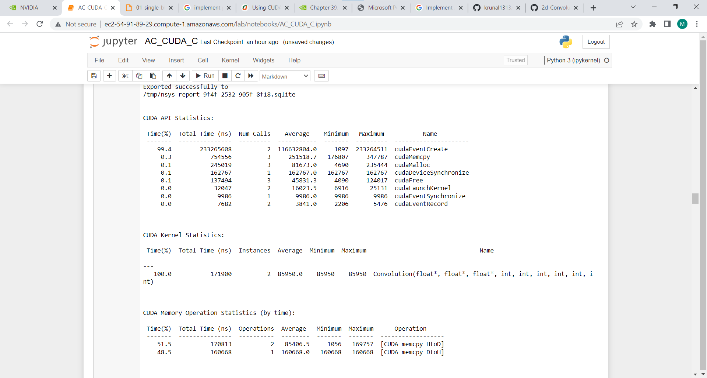

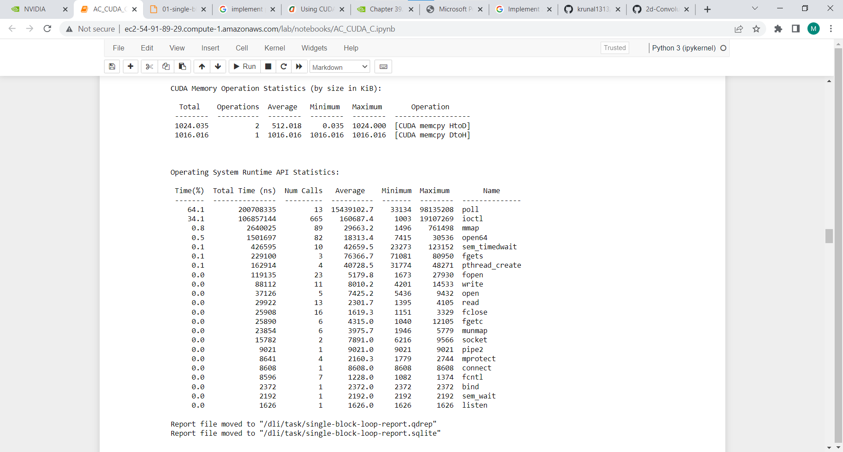

**Information #:**

#include <stdio.h>

#include <cstdlib>

#include <time.h>

#define BLOCK_SIZE 32

#define WA 512

#define HA 512

#define HC 3

#define WC 3

#define WB (WA - WC + 1)

#define HB (HA - HC + 1)

__global__ void Convolution(float* A, float* B, float* C, int numARows, int numACols, int numBRows, int numBCols, int numCRows, int numCCols)

{

int col = blockIdx.x * (BLOCK_SIZE - WC + 1) + threadIdx.x;

int row = blockIdx.y * (BLOCK_SIZE - WC + 1) + threadIdx.y;

int row_i = row - WC + 1;

int col_i = col - WC + 1;

float tmp = 0;

__shared__ float shm[BLOCK_SIZE][BLOCK_SIZE];

if (row_i < WA && row_i >= 0 && col_i < WA && col_i >= 0)

{

shm[threadIdx.y][threadIdx.x] = A[col_i * WA + row_i];

}

else

{

shm[threadIdx.y][threadIdx.x] = 0;

}

__syncthreads();

if (threadIdx.y < (BLOCK_SIZE - WC + 1) && threadIdx.x < (BLOCK_SIZE - WC + 1) && row < (WB - WC + 1) && col < (WB - WC + 1))

{

for (int i = 0; i< WC;i++)

for (int j = 0;j<WC;j++)

tmp += shm[threadIdx.y + i][threadIdx.x + j] * C[j*WC + i];

B[col*WB + row] = tmp;

}

}

void randomInit(float* data, int size)

{

for (int i = 0; i < size; ++i)

data[i] = rand() / (float)RAND_MAX;

}

int main(int argc, char** argv)

{

srand(2006);

cudaError_t error;

cudaEvent_t start_G, stop_G;

cudaEventCreate(&start_G);

cudaEventCreate(&stop_G);

unsigned int size_A = WA * HA;

unsigned int mem_size_A = sizeof(float) * size_A;

float* h_A = (float*)malloc(mem_size_A);

unsigned int size_B = WB * HB;

unsigned int mem_size_B = sizeof(float) * size_B;

float* h_B = (float*)malloc(mem_size_B);

unsigned int size_C = WC * HC;

unsigned int mem_size_C = sizeof(float) * size_C;

float* h_C = (float*)malloc(mem_size_C);

randomInit(h_A, size_A);

randomInit(h_C, size_C);

float* d_A;

float* d_B;

float* d_C;

error = cudaMalloc((void**)&d_A, mem_size_A);

if (error != cudaSuccess)

{

fprintf(stderr, "GPUassert: %s in cudaMalloc for A\n", cudaGetErrorString(error));

return EXIT_FAILURE;

}

error = cudaMalloc((void**)&d_B, mem_size_B);

if (error != cudaSuccess)

{

fprintf(stderr, "GPUassert: %s in cudaMalloc for B\n", cudaGetErrorString(error));

return EXIT_FAILURE;

}

error = cudaMalloc((void**)&d_C, mem_size_C);

if (error != cudaSuccess)

{

fprintf(stderr, "GPUassert: %s in cudaMalloc for C\n", cudaGetErrorString(error));

return EXIT_FAILURE;

}

error = cudaMemcpy(d_A, h_A, mem_size_A, cudaMemcpyHostToDevice);

if (error != cudaSuccess)

{

fprintf(stderr, "GPUassert: %s in cudaMemcpy for A\n", cudaGetErrorString(error));

return EXIT_FAILURE;

}

error = cudaMemcpy(d_C, h_C, mem_size_C, cudaMemcpyHostToDevice);

if (error != cudaSuccess)

{

fprintf(stderr, "GPUassert: %s in cudaMemcpy for C\n", cudaGetErrorString(error));

return EXIT_FAILURE;

}

dim3 threads(BLOCK_SIZE, BLOCK_SIZE);

dim3 grid((WB - 1) / (BLOCK_SIZE - WC + 1), (WB - 1) / (BLOCK_SIZE - WC + 1));

Convolution << < grid, threads >> >(d_A, d_B, d_C, HA, WA, HB, WB, HC, WC);

cudaEventRecord(start_G);

Convolution << < grid, threads >> >(d_A, d_B, d_C, HA, WA, HB, WB, HC, WC);

error = cudaGetLastError();

if (error != cudaSuccess)

{

fprintf(stderr, "GPUassert: %s in launching kernel\n", cudaGetErrorString(error));

return EXIT_FAILURE;

}

error = cudaDeviceSynchronize();

if (error != cudaSuccess)

{

fprintf(stderr, "GPUassert: %s in cudaDeviceSynchronize \n", cudaGetErrorString(error));

return EXIT_FAILURE;

}

cudaEventRecord(stop_G);

cudaEventSynchronize(stop_G);

error = cudaMemcpy(h_B, d_B, mem_size_B, cudaMemcpyDeviceToHost);

if (error != cudaSuccess)

{

fprintf(stderr, "GPUassert: %s in cudaMemcpy for B\n", cudaGetErrorString(error));

return EXIT_FAILURE;

}

float miliseconds = 0;

cudaEventElapsedTime(&miliseconds, start_G, stop_G);

printf("Time took to compute matrix A of dimensions %d x %d on GPU is %f ms \n \n \n", WA, HA, miliseconds);

//for (int i = 0;i < HB;i++)

//{

// for (int j = 0;j < WB;j++)

// {

// printf("%f ", h_B[i*HB + j]);

// }

// printf("\n");

//}

free(h_A);

free(h_B);

free(h_C);

cudaFree(d_A);

cudaFree(d_B);

cudaFree(d_C);

return EXIT_SUCCESS;

}

**Github Link:**

<https://github.com/Kunalkadam179/HPC-Assignment/tree/main/Assignment%20-%2010>